Software Design Document
GreatKart E-Commerce Website



Submitted by
Qudsia Amber (S23BINFT1M01074)

Submitted to
Mam Sara Fareed

Department of Information Technology
Faculty of Computing
The Islamia University of Bahawalpur

Summary
This Software Design Document presents the design and implementation overview of a comprehensive E-commerce Web Application developed to facilitate online shopping for users while providing a robust administrative management system for product and order control. The system is designed to ensure a seamless interaction between customers and administrators through a secure, scalable, and user-friendly platform.
The primary objective of the system is to enable users to browse products, search and filter items, manage a shopping cart, and place orders efficiently through an intuitive interface. At the same time, administrators are provided with a dedicated dashboard to manage products, categories, and customer orders, ensuring smooth backend operations and effective system control.
From a design perspective, the system is based on a Client-Server architecture, where the front-end handles user interaction and the back-end processes data management, authentication, and order handling. The system follows a modular design approach, dividing functionality into User, Admin, and Back-end modules to ensure separation of concerns and maintainability.
The development approach emphasizes procedural programming principles, focusing on simplicity, structured logic, and efficient implementation of core features such as authentication, product management, cart operations, and order processing.
The system incorporates key design models including class diagrams, sequence diagrams, state transition diagrams, and data flow diagrams (DFD) to represent system behavior and structure. The data architecture is implemented using a MongoDB NoSQL database, consisting of collections for Users, Admins, Products, and Orders, enabling flexible, scalable, and efficient data management.
Security and functionality are ensured through features such as user authentication, role-based access control, cart management, order placement, and profile management. Algorithms for core processes including registration, login, cart operations, profile updates, and logout have been defined to ensure proper system workflow and reliability.
The system also emphasizes a user-friendly interface with responsive design, ensuring compatibility across multiple devices such as desktops, tablets, and smartphones.
Overall, the proposed e-commerce platform provides a complete, scalable, and efficient solution for online shopping (with cash on delivery), integrating modern web technologies and best practices in software engineering to ensure maintainability, usability, and future extensibility.

Table of Content

1.Application Architecture………………………………………………………………………………...............

1.1 Architectural Design…………………………………………………………………………………................

1.2 Process Flow / Representation………………………………………………………………………..............

1.3 Design Models…………………………………………………………………………………………...............

Class Diagram…………………………………………………………………………………………..............

Sequence Diagram…………………………………………………………………………………………........

Data Flow Diagram (DFD) ………………………………………………………………………………............

State Transition Diagram………………………………………………………………………………..............

1.4 Data Design……………………………………………………………………………………………….............

Users Collection………………………………………………………………………………………………..

Admin Collection………………………………………………………………………………………………...

Products Collection………………………………………………………………………………………………

Orders Collection………………………………………………………………………………………………..

1.5 Algorithm & Implementation……………………………………………………………………………………...

Algorithm for Registration Page…………………………………………………………………………………

Algorithm for Login Page………………………………………………………………………………………………………………………………………

Algorithm for Update Profile…………………………………………………………………………………………………………………………………

Algorithm for Managing Cart…………………………………………………………………………………………………………………………………

Algorithm for Log Out………………………………………………………………………………………………

2. Data Model Schema……………………………………………………………………………………………

2.1 User Entity……………………………………………………………………………………………………….

2.2 Product Entity……………………………………………………………………………………………………

2.3 Order Entity………………………………………………………………………………………………………

2.4 Admin Entity………………………………………………………………………………………………………

2.5 Cart Entity (Logical / Session-Based Entity) ……………………………………………………………………………………………………

2.6 Overall Relationship Summary……………………………………………………………………………………

2.7 ER Diagram…………………………………………………………………………………………………………

3.User Interface……………………………………………………………………………………………………….

3.1 Human Interface Design…………………………………………….………………………………………………

3.2 Screen Objects and Actions…………………………………………………………………………………………
3.3 Screen Images………………………………………………………………………………………………………

Application Architecture

Architecture Design
The system is designed with a Client-Server architecture, where the front-end (client) interacts with the back-end (server) to fetch Products data process orders and handle authentication.
Key Modules:
- User Module – Handles user authentication, product display, cart management and order placement.
- Admin Module – Manages product, order updates and order status tracking.
- Back-end Module – Facilitates API calls for product data, cart management and order processing.

Process flow/Representation
The major processes in the system are represented in the following:
- User Flow:
  - Browse Product → 2. Add to Cart → 3. Review Cart → 4. Place Order
- Admin Flow:
  - Add/Edit/Delete Product → 2. View Orders → 3. Update Order Status

Design models
The Class Diagram represents the main objects in the system and their relationships.
- Class Diagram:
User: Attributes include user ID, name, email, password; Methods include sign In(), sign Up(), view Cart() and place Order().
Admin: Attributes include admin ID, name; Methods include addProduct() updateOrderStatus().
Product: Attributes include productID name price category image Methods include addProduct(), updateProduct().
Order: Attributes include orderID, userID, ProductItems, status; Methods include placeOrder() updateStatus().
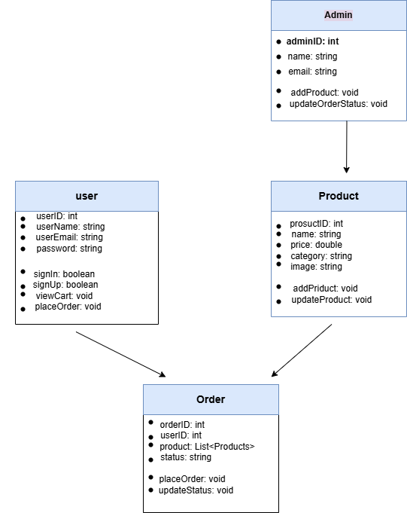
Figure 1 Class diagram

Sequence Diagram

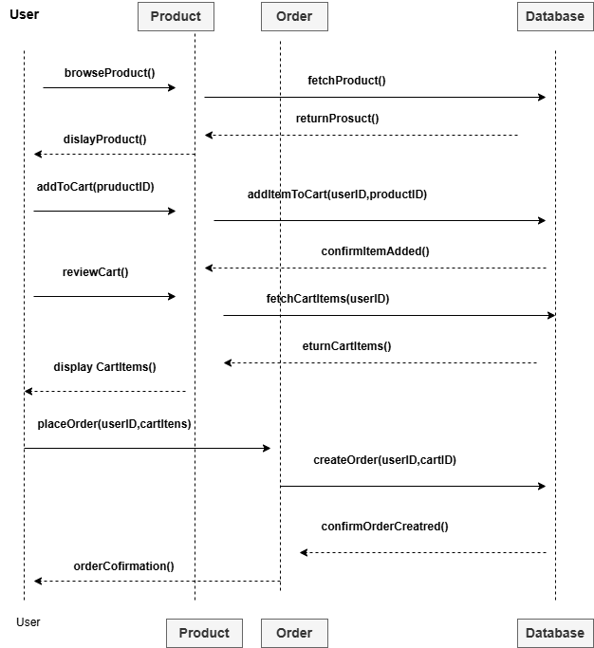
Figure 2 state transition diagram

Data Flow Diagram (DFD)
how data flows between the system and external entities, including users, admins, and the Database on our web-system.

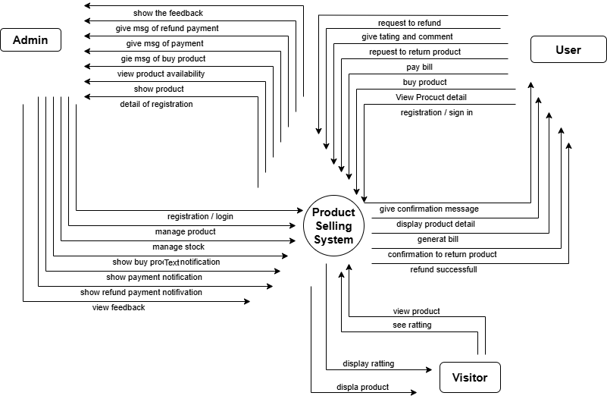
Figure 3Data Flow Diagram

- Admin: Manage product, stock, payments, refunds, and view feedback.
- User: perform actions like registration/login, buying product, requesting refund, viewing detail and paying bills
- System: Handles confirmations (purchase / return), displays product details, generate bills and shows notifications (payment / refund)
- State Transition Diagram

- 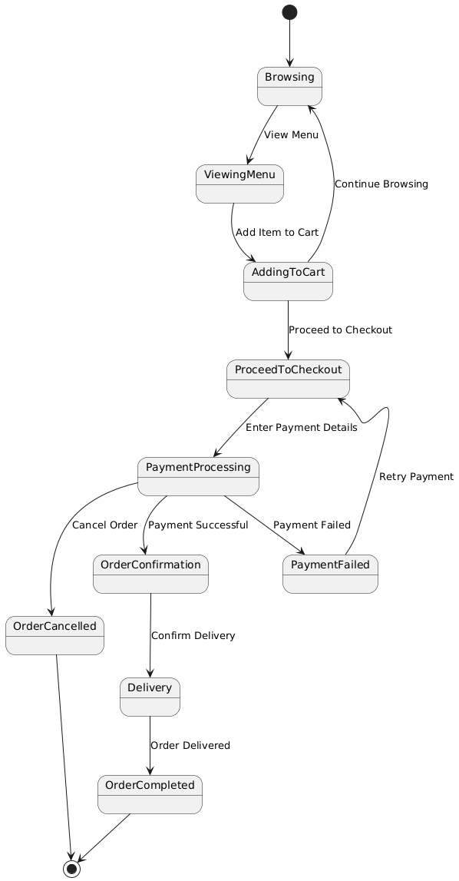
- Figure 4 state Transition Diagram

Data design

This website uses MongoDB a NoSQL document-oriented Database to store and manage data. Instead of tables it is used collections in MongoDB. This design provides flexibility and scalability of the website

Users Collection

Field Name | Type | Description
-id | ObjectId | Auto generated Unique Id
name | String | Full name of the user
email | String | User e-mail (should be unique)
password | String | Hashed user Password
Phone | String | Contact number
address | String | Shipping Address
createdAt | Date | Timestamp of account creation
role | String | Should be user

Admin Collection
Field Name | Type | Description
-id | ObjectId | Auto generated Unique Id
name | String | Full name of the admin
email | String | Admin e-mail (should be unique)
password | String | Hashed admin Password
Phone | String | Contact number
role | String | Should be admin
createdAt | Date | Timestamp of account creation

Products Collection
Field Name | Type | Description
-id | ObjectId | Auto generated Unique Id
name | String | Product name
category | String | Product category
description | String | Product description
price | Number | Product price
stock | Number | Available quantity in stock
images | Array | List of image URLs
addedBy | ObjectId | Admin ID who added the product
createdAt | Date | Timestamp when product was added

Orders Collection
Field Name | Type | Description
-id | ObjectId | Auto generated Unique Id
UserId | ObjectId | Reference to the user who placed the order
Product | Array | List of product order (with price and quantity)
totalAmount | Number | Total cost of order
status | String | i.e. pending, shipping, delivered
deliveryAddress | String | Address to which the order will be shipped
orderDate | Date | Date and time the order was placed
deliveryDate | Date/Null | Delivery date (if delivered)

Algorithm & Implementation

Algorithm for Registration Page
- Start
- Display the registration form with fields: username, email, password, confirm password and other necessary details.
- Wait for the user to input data into the form fields.
- Validate the input:
  - Ensure all fields are filled.
  - Check if password matches confirm password.
  - Verify the email format using regex.
- Check if the username or email already exists in the database.
  - If yes, display an error message: "Username or email already exists."
  - If no, proceed to the next step.
- Encrypt the password using a secure hashing algorithm (e.g. bcrypt).
- Save the user details into the database Users table.
- Display a success message: Registration successful.
- Redirect the user to the login page.
- End

Algorithm for Login Page
- Start
- Display the login form with fields: username and password.
- Wait for the user to input the credentials.
- Validate the input:
  - Ensure both fields are filled.
  - Fetch the corresponding username and encrypted password from the database.
- Compare the entered password with the stored encrypted password.
  - If it matches proceed to step 6.
  - If not display an error message: "Invalid username or password."
- Create a session for the user and store their user id.
- Redirect the user to the home page or dashboard.
- End

Algorithm for Update Profile
- Start
- Authenticate the user to ensure they are logged in.
- Fetch the current user profile data from the database.
- Display the profile update form pre-filled with the user's data (e.g., name, email phone etc.).
- Wait for the user to update the fields and submit the form.
- Validate the updated input:
  - Ensure required fields are filled.
  - Check the email format using regex.
- Save the updated details into the database.
- Display a success message: profile updated successfully.
- Redirect the user to their profile page.
- End

Algorithm for Managing Cart
- Start
- Authenticate the user to ensure they are logged in.
- Display the current items in the cart fetched from the Cart table in the database.
- Wait for the user to perform actions:
  - Add an item:
    - Select the product and quantity.
    - Check product availability in the inventory.
    - If available add the item to the cart and update the database.
  - Update quantity:
    - Select the item to update.
    - Modify the quantity and update the database.
  - Remove an item:
    - Select the item to remove.
    - Delete it from the cart in the database.
- Recalculate the cart total and update the UI.
- Display the updated cart to the user.
- End

Algorithm for Log Out
- Start
- Check if the user is logged in.
  - If not logged in, display a message: You are not logged in.
  - If logged in, proceed to the next step.
- Destroy the user's session and clear session data.
- Redirect the user to the login page.
- Display a success message: You have been logged out.
- End

- Data Model Schema
The data model of the E-Commerce Website is designed to manage users, products, orders, and administrative operations in a structured and scalable manner. The system follows a NoSQL (MongoDB) based relational-like structure where collections represent entities and references define relationships between them. This ensures flexibility, scalability, and efficient data handling for online shopping operations.
2.1 User Entity

The User entity represents customers who use the platform to browse products, manage their cart, and place orders. It is also responsible for authentication and maintaining user-specific information.

- Attributes:
- _id (Primary Key)
- name
- email
- password
- phone
- address
- role (user)
- createdAt
Working Properties:

The User entity handles registration, login, and session management. It allows users to securely access the system and perform shopping operations such as adding items to cart and placing orders. Passwords are stored in encrypted form to ensure security. Each user is uniquely identified and linked with their respective orders.

Relationships:
- User (1) → (M) Orders
- One user can place multiple orders.
- User (1) → (M) Cart Items (logical relationship)
- Each user manages their own shopping cart.
- Connected to Order collection via UserId (Foreign Reference)

2.2 Product Entity

The Product entity represents all items available for sale on the platform. It is managed by the administrator and displayed to users for purchasing.

Attributes:
- _id (Primary Key)
- name
- category
- description
- price
- stock
- images
- addedBy (Admin ID)
- createdAt
Working Properties:
The Product entity stores complete product information including pricing, availability, and images. It is used for product listing, searching, filtering, and inventory management. Stock levels are updated dynamically based on orders placed by users. Only administrators have permission to create, update, or delete products.

Relationships:
- Product (1) → (M) Orders
- A product can exist in multiple orders.
- Product (M) → (1) Admin
- Each product is added/managed by an admin.
- Included in Order as a sub-document array (ProductItems)

2.3 Order Entity

The Order entity is the core transactional component of the system that records all purchases made by users.

Attributes:
- _id (Primary Key)
- userId (Foreign Key)
- product (Array of ordered items)
- totalAmount
- status (pending / shipping / delivered)
- deliveryAddress
- orderDate
- deliveryDate
Working Properties:
The Order entity manages the complete lifecycle of a purchase, from order placement to delivery. It stores product details, quantities, and pricing at the time of purchase. Order status is updated by the admin during processing. It ensures accurate tracking of customer purchases and supports order history retrieval for users.

Relationships:
Order (M) → (1) User
Order contains multiple Products (embedded relationship)
Controlled by Admin for status updates

2.4 Admin Entity
The Admin entity represents system administrators responsible for managing products and orders.

Attributes:
- _id (Primary Key)
- name
- email
- password
- phone
- role (admin)
- createdAt
Working Properties:
The Admin entity controls backend operations of the e-commerce system. It is responsible for product management, order processing, and system monitoring. Admin users have elevated privileges compared to normal users.

Relationships:
- Admin (1) → (M) Products
Admin adds and manages products.
- Admin (1) → (M) Orders (indirect control)
Admin updates order status.

2.5 Cart Entity (Logical/Session-Based Entity)

The Cart entity represents temporary user-selected items before order placement. It is usually stored in session or database depending on implementation.
Attributes:
- productId
- userId
- quantity
- price
- totalPrice
Working Properties:
The Cart entity allows users to temporarily store selected products before final purchase. It supports operations such as add item, remove item, update quantity, and calculate total price dynamically. Once an order is placed, cart data is transferred into the Order entity.

Relationships:
- Cart (M) → (1) User
- Cart (M) → (1) Product
2.6 Overall Relationship Summary

The system follows these core relationships:

- User (1) → (M) Orders
- User (1) → (M) Cart Items
- Product (1) → (M) Orders (via order items)
- Admin (1) → (M) Products
Order contains embedded Product array (many products per order)
2.7 ER Diagram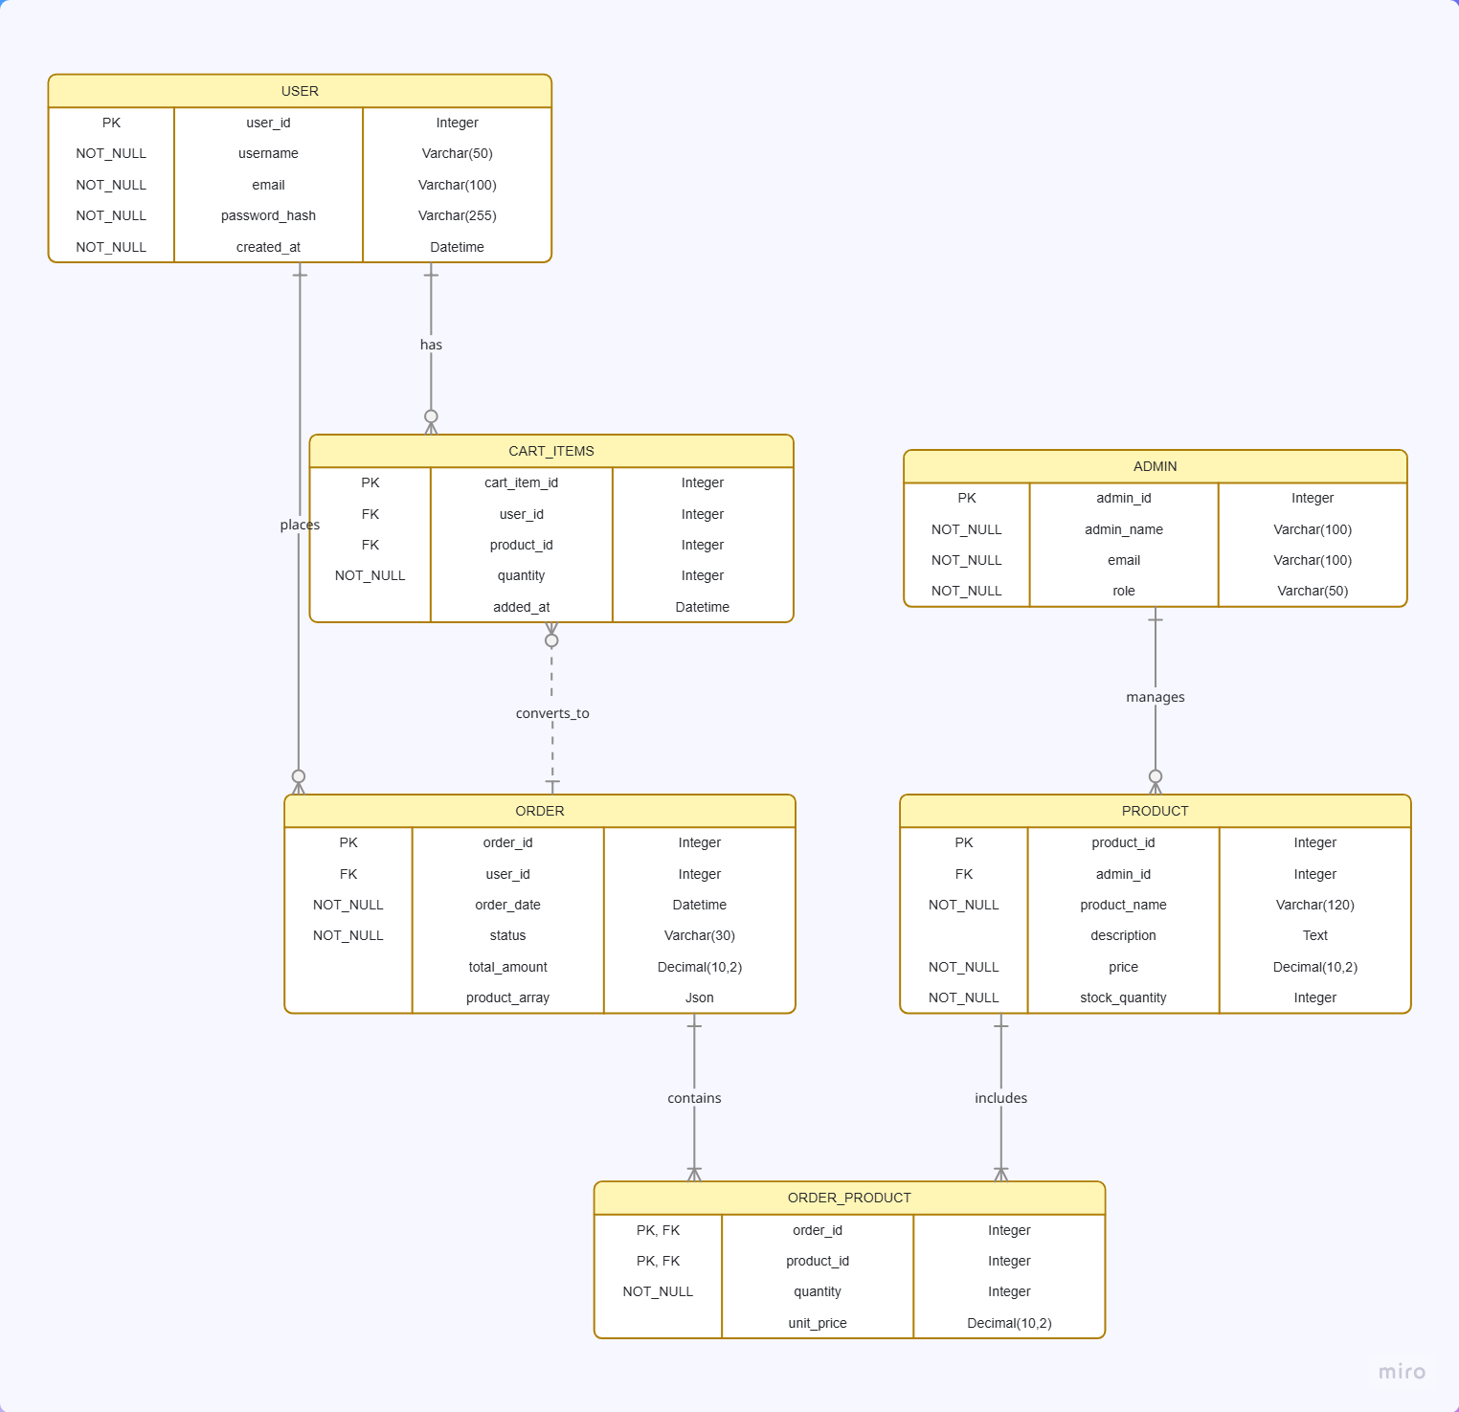
- User Interface

3.1 Human interface design
The user interface (UI) is designed to be intuitive and easy to use. Key features include:
- Product display Page: Displays products with images, names prices and categories.
- Cart Management: Allows users to view added items modify quantities and remove items.
- Order Confirmation: A confirmation page allows users to review their cart before placing the order.
Screen Objects and Actions:
- Product: Each product is displayed as a card with an image, name and price. Clicking on it opens the product details.
- Cart: A list of selected products each with options to increase quantity decrease quantity or remove.

Screen images
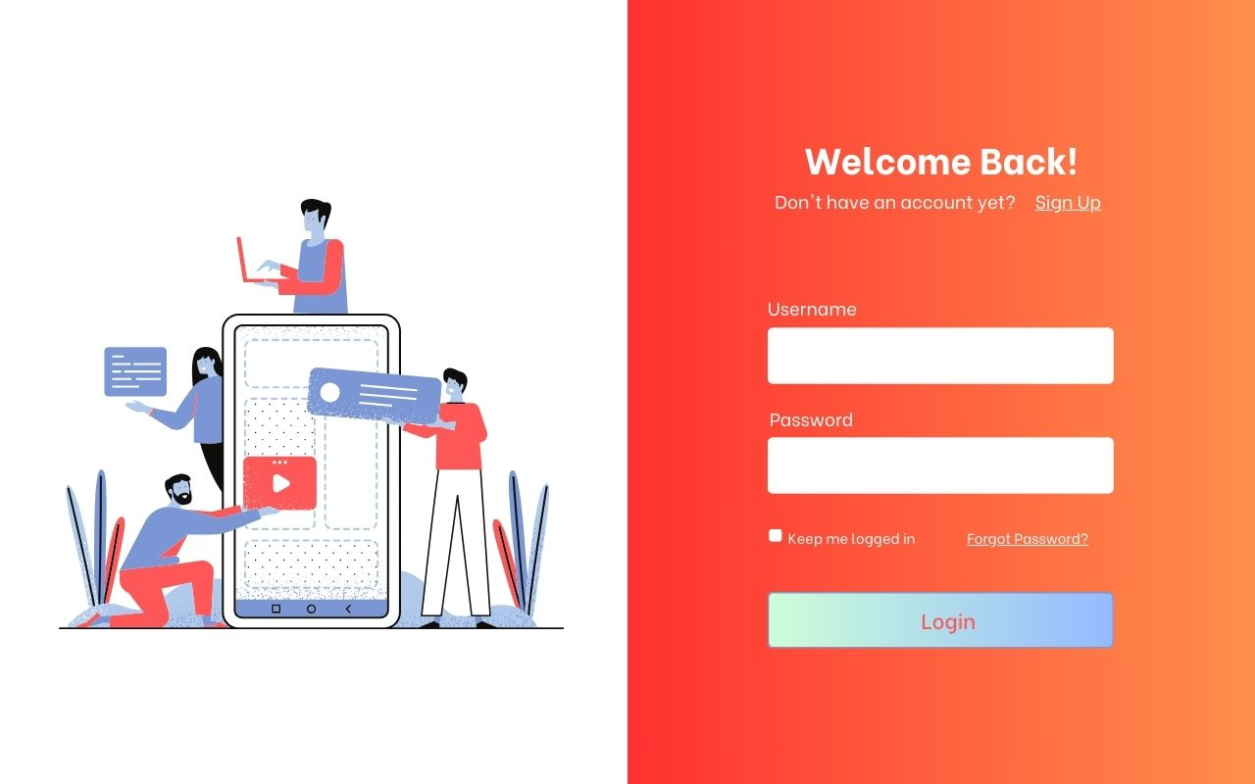
Figure 5 Login

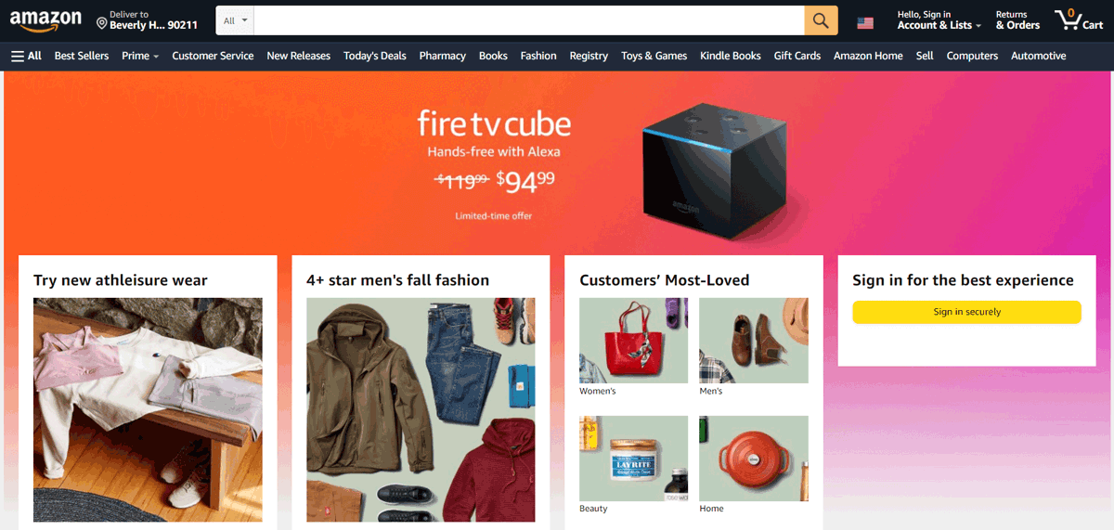
Main Page
Figure 6 Main Page

Add to Cart
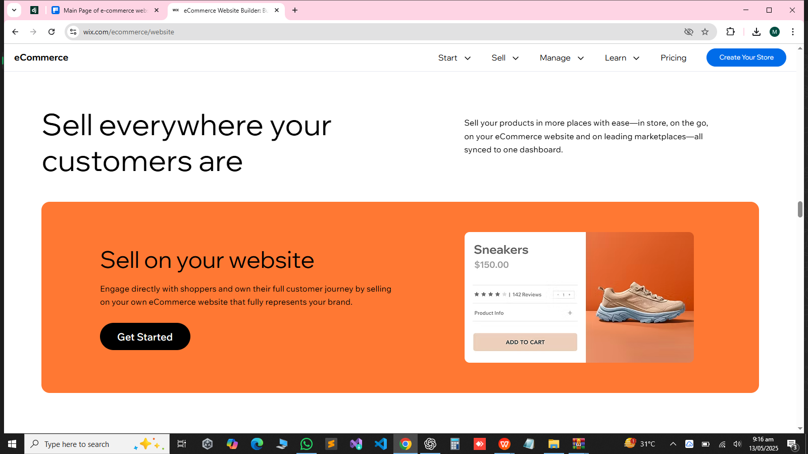
Figure 7 Add to Cart

